# Meeting 5

Rui Castro & Richard Post, Alexander Mey, Martin, 06-10-2021, duration: 75 minutes.

Discussed a lot, brief introduction of the problem to both Alex and Richard, our formulation of solving the problem. 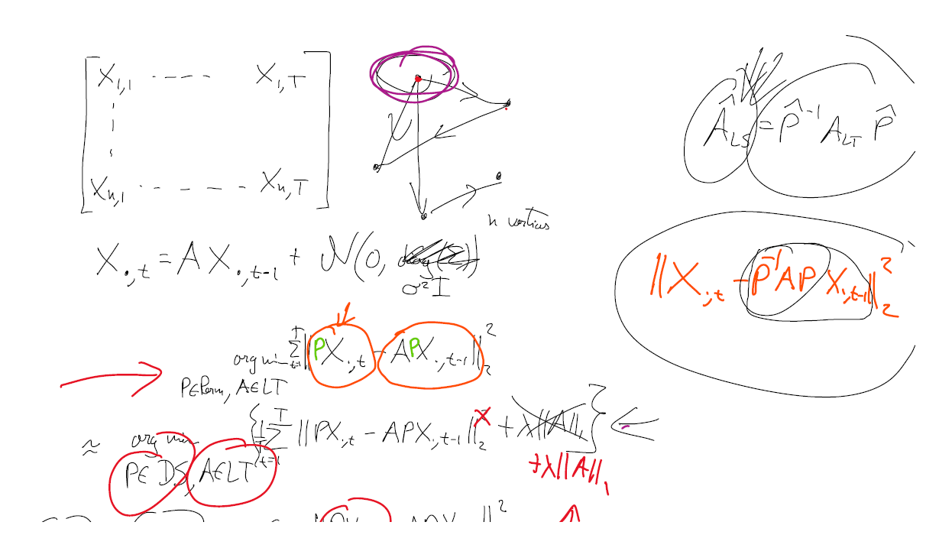

We discussed why the model fails. Most likely because giving it the relaxations, it has too much wiggle room, even achieving costs lower than the “optimal”. We need to change our constraints, most likely on P. A good starting point is by constraining the LHS to be a permutation matrix.

For example, generate *n* series with permutation matrix *P* and matrix *A*. It achieves a cost of *n* times the variance of the process, even if you use the *perfect P* and *A*. However, if you only constrain P to be DS, and A to be LT, then we can find an optimal solution that achieves a cost much lower, indicating that we are not solving the problem we had in mind.

The P on the LHS makes quite some struggles if it is not a permutation matrix. It mixes all n entries in the LHS, such that constraining A to be LT does not make much sense anymore.

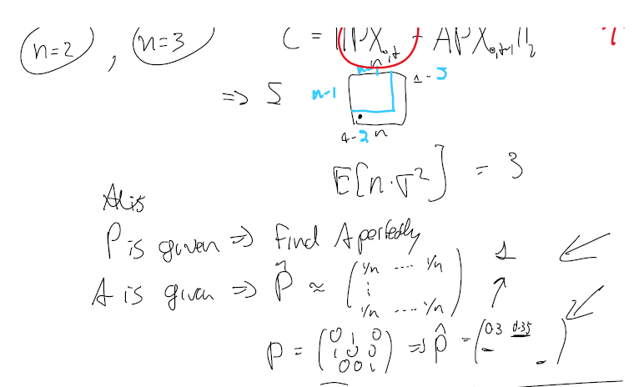

Approaches:

* Sample from P_DS to get P_PERM. -> No sampling, but Hungarian Algorithm.
* Try permutation matrices P and see if the results make sense. Yes.
* Check whether it makes sense for higher dimensions (n = 3, …).
* Rather than ||P_DS X – A P_DS X||, try ||P_perm X – A P _DS X||. Tried, optimizing is difficult due to discontinuities.
* Anchor Regression
* Check Joris Mooij, greedy DAG search (combinatorial).
* Mixed Integer Linear Programming
* Use 1 norm